The software product to be designed will control a mimicked robotized teller machine (ATM) having an attractive stripe reader for perusing an ATM card, a console or display for interaction with the client or customer, a space for storing envelopes, a dispenser for cash (in multiples of $10), a printer for printing client receipts, and a key-worked change to enable an administrator to begin or stop the machine. The ATM will speak with the bank's PC or server over a suitable communication link.

The ATM will benefit one client / customer at a time. A client will be required to put an ATM card and enter an individual distinguishing proof number (PIN) - both of which will be sent to the bank for approval as a major aspect of every transaction. The client will then have the capacity to perform at least one transaction. The card will be held in the machine until the point when the client demonstrates that he/she wants no further transactions, and soon thereafter it will be returned - with the exception of as noted beneath.

The ATM must have the capacity to give the following services to the client:

1. A client must have the capacity to make a money withdrawal from any reasonable account connected to the card, in multiples of $10.00. Endorsement must be gotten from the bank before money is dispensed.
2. A client must have the capacity to make a deposit to any account connected to the card, comprising of money as well as checks in an envelope. The client will enter the amount of the deposit into the ATM, subject to manual check when the envelope is expelled from the machine by an administrator. Endorsement must be gotten from the bank before physically tolerating the envelope.
3. A client must be able to make a balance inquiry of any account linked to the card.

The ATM will convey every transaction to the bank and get check that it was permitted by the bank. On account of a money withdrawal or deposit, a second message will be sent after the transaction has been physically finished (money dispensed or envelope acknowledged).

If the bank determines that the client's PIN is invalid, the client will be required to re-enter the PIN before a transaction can continue. In the event that the client can't effectively enter the PIN after three tries, the card will be for all time held by the machine, and the client should contact the bank to get it back

In the event that a transaction fails for any reason other than an invalid PIN, the ATM will show a clarification of the issue, and will then ask the client whether he/she needs to do another transaction.

The ATM will give the customer a printed receipt for each powerful transaction, exhibiting the date, time, machine zone, kind of transaction, account(s), total, and completing and available balance(s) of the affected account.

The ATM will have an operator panel with a key-worked switch (situated "within the bank" side) that will enable an operator to begin and stop the servicing of clients. At the point when the change is moved to the "off" position, the machine will close down, so the operator may expel store envelopes and reload the machine with money, clear receipts, and so forth. The operator will be required to confirm and enter the money close by before starting the ATM machine from this panel.

**Class Diagram**

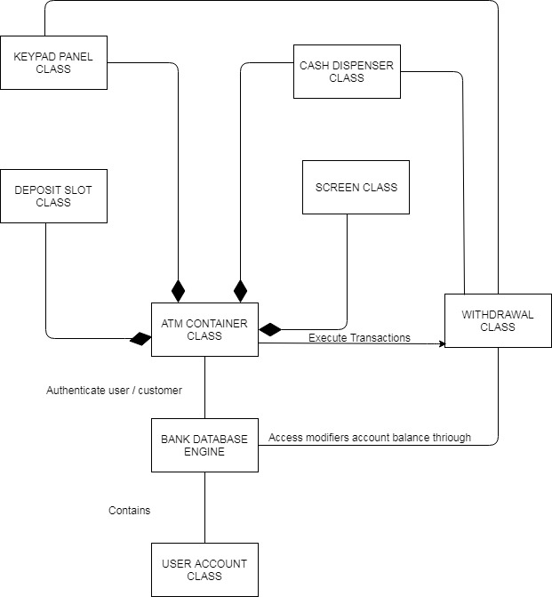

https://drive.google.com/file/d/1LyoomasHTmWksxSw-KB2tl2d_sClQ-OX/view?usp=sharing

**CRC cards**

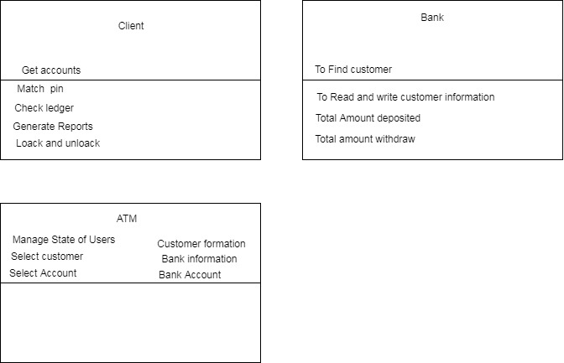

https://drive.google.com/file/d/11RXurVgc6v4iRogltiv9DwU4Aj-a3rRe/view?usp=sharing

‘

**State Diagram**

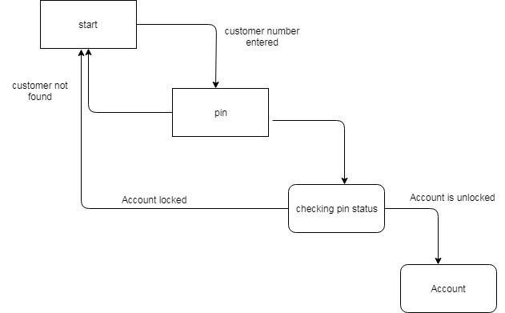

https://drive.google.com/file/d/1lis78lLqNPyoOgiPgLe-FwQaqUJvFidN/view?usp=sharing

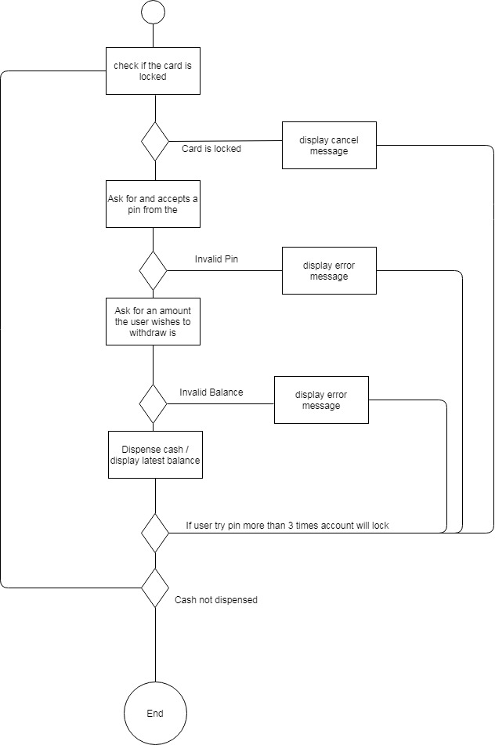

https://drive.google.com/file/d/1t2Sy-WGwXxptKvyCwUT5XepNhuhF1tZd/view?usp=sharing

**User stories**

**As a Customer**

I need to Login to my financial account I need to pay my certain amount to my client

Acknowledgment Criteria –

• Software must verify the card and check and verify existing balance

• In case Customer enters wrong Pin code more than three times then the software must halt the execution.

**As a Customer**

I need to check and verify my ledger.

Acknowledgment Criteria

• Customer should be signed in before checking balance.

• Balances is shown to customer and if he needs transaction summary software must generate a financial report

**As a Customer**

I need to verify my financial balance through ATM So that I may save my time and to go bank and get summary report

Acknowledgment Criteria

Customer should be signed in before depositing money

* System ought to confirm the user ledger
* If the client doesn't submit the correct information the currency must return back to customer.
* If all the transaction is ok then software must generate appropriate logs of client usage.

**As a Customer**

I need to pull back money from my ledger through ATM So that I may save my time

Acknowledgment Criteria

* Customer should be signed in before pulling back money.
* System verifies whether the demand of amount is not surpasses the actual amount
* If the input amount is more than system ask to put another amount

**As a Customer**

I want to logout from my bank account through ATM So that I may end up my ATM session

Acceptance Criteria

* Software send messages to user if the user wants current session summary report and receipt for the complete session.
* If yes then the receipt is dispensed
* User is logged off from the account

**An Automatic Teller Machine — Source code analysis**

In this software we have two classes account.java, Atmcard.java. “Account.java” provides two functions the one is Boolean function debit serve as utility function to check an verify the enough amount is available for withdrawal and the other one is return back the available amount in account. I think this class provide more functions for customer like

* User able to generate different reports of his ledger.
* User last session must stored in database.
* Multiple attempts on particular account must be stored in database.
* Last pin code change must be stored in database.
* How many times user try to pull back amount more than available balance.
* One more the ip address logged as evidence of user session from different locations.

“Atmcard.java” provides us three functions first is “pinok” serve to check the entered pin is matched in database, “lockCard” serve as to restrict the user if he fails to put right information in console, isLocked is a utility function give class user a flexibility to verify the account status of the user. Here we also require more methods and functions which are given below

* The ip address must record or save on database
* Last pin change information.
* How many times the card get locked
* How many time user try to get more than in the available balance.

**Test Plan**

The current version of this software should use the normal desktop computer’s monitor to simulate the ATM screen and the normal computer keyboard to simulate the ATM keypad. This proposal will verify the only dedicated items that is directly associated with the ATM transaction method and account both directly and indirectly pr. The current scope of this strategy is to make sure that the purpose ATM system provides the authenticated and accurate information from the bank as simulation and offer a secured transaction way to the existing customer base using an ATM card. The software must comply the standard behavior

Test Item the following list of the items to need be tested:

**Requirements specification**

* Classes and functions
* Program files / source code
* Abstract Interfaces and methods
* Utility Functions

**Features to Test Data flows**

**Use-Cases**

* State diagrams specially pin lock
* Activity diagram like stated above in diagram
* Functions and methods listed in source code
* Withdraw cash how can a user certain amount from the system
* Balance inquiries, generate reports summary and detailed transactions.

**Transactions**

* Deposit of amount
* Sessions of different types like (View, withdraw, deposit)
* Operator panel / key operator panel.